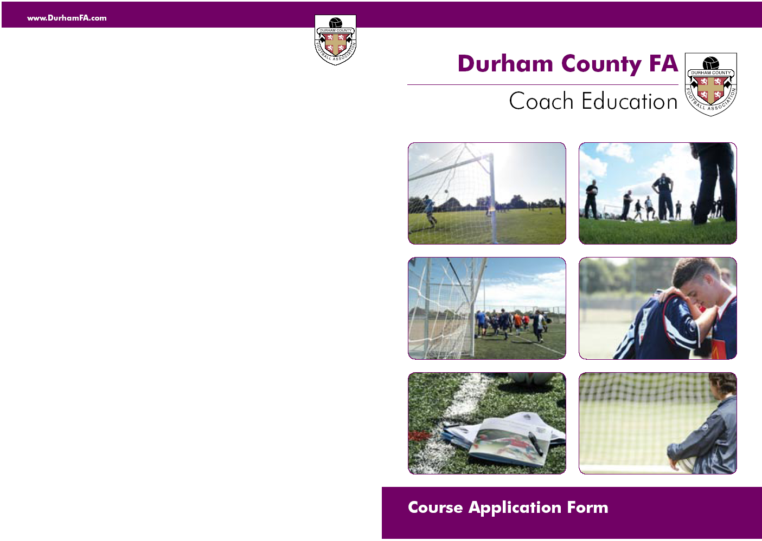

Football Association

Basic First Aid For Sport

Venue; Steels Social Club, 1 Peacock Street West, Sunderland, Tyne & Wear, SR4 6LQ
____________________________________________________________

Monday 9th July 6.00 – 9.00 pm Module 1
Monday 16th July 6.00 – 9.00 pm Module 2
Monday 23rd July 6.00 – 9.00 pm Module 3
__________________________________________________________________
Course Syllabus:-
Module 1 Emergency Aid ( Must have attended a HSE Approved workshop 6mths prior to the start of the course to be exempt from the 1st Module)
Module 2 Common Musculo-Skeletal Injuries “On Field” Assessment Module 3 Common Medical Conditions

Assessment
Multi Choice Questionnaire (15/20 pass requirement)
Oral Interview/Questioning of understanding
__________________________________________________________________
Cost:- £Free

Normal Cost £55.00
All application forms for a bursary must be co-signed by a club secretary otherwise application form will be returned.
Any candidate who applies for the course and fails to attend/complete will be charged the full (Normal Course Fee £55.00 in accordance to the DCFA Cancellation policy)
________________________________________________________________________________
Tel: 0191 3872928
E-mail: development@durhamfa.com
Web: www.durhamfa.com

Course Code BFAS10
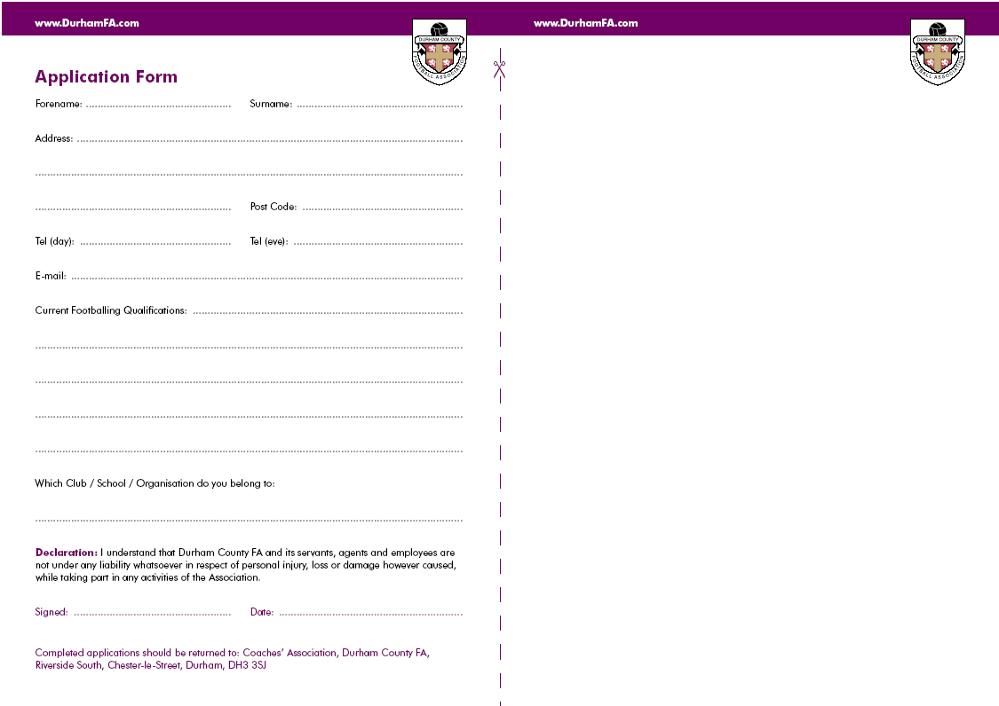
Durham FA Coach Education Cancellation Policy

If you need to cancel your attendance on the course you should inform Durham FA immediately. All our courses are in demand and by not advising us you are preventing another candidate from attending.

If you cancel more than 2 weeks prior to the commencement of the course, a full refund will be issued. However, if you cancel after the 2 week deadline, no refund will be given. Consideration will be given to candidates who, for health reasons are unable to attend and require a transfer to another course. A letter from a doctor or medical professional must be supplied.

If you should decide to transfer to another course once your application has been submitted, there will be an additional administration charge of £20.00

By submitting an application you agree to all of the terms above
Getting your
Guidance Notes

If you are a League Official, Club Official, Referee, Coach and/or Player it is extremely likely you have a FAN already.
Please email: GetOnline@TheFA.com with your name, date of birth and address and your FAN and password will
be emailed to you.

You can also register for a FAN at www.TheFA.com/FAN

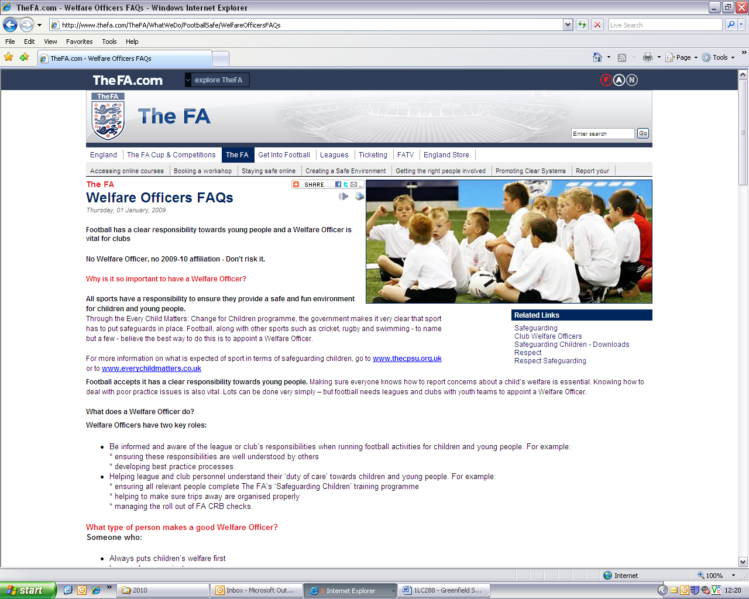
Course Code: BFAS10
:
Basic First Aid For Sports Course

For whom the course is intended

- Minimum age is 16 years
- Managers/Coaches of junior football teams
- Mini-Soccer organisers and officials
- Volunteers within football clubs

Course Content

Module 1 – General Principles of First Aid

Pre-activity Preparation, Reacting to an Incident, The Recovery Position, Choking, Shock, The Emergency Action Plan, The Primary & Secondary Survey CPR, Severe External/Internal Bleeding

Module 2 – Common Musculo-Skeletal Injuries “On Field” Assessment

Basic Injury Recognition, Ligament Injuries-Sprains, On Field Injury Assessment “SALTAPS”, Head/Spinal Injury, Fractures/Dislocation, Muscle Injury-Strains/Contusions, Management of Acute Soft Tissue Injury, Skull/Cheekbone/Nose/Jaw & Rib Fractures

Module 3 – Common Medical Conditions

Anaphylaxis, Asthma, Seizure, Diabetes, Hypothermia, Cramp, Dehydration, Foreign Body in the Eye, First Aid Kit Contents, After an Emergency Incident

Assessment & Certification

20 Minute Multi Choice Questionnaire (15/20 pass requirement)
5 Minute Oral Questioning relating to the students knowledge and understanding of the course content

Forename: …………………………………………….. Surname: …………………………………………….

Address: ………………………………………………………………………………………………………………….

…………………………………………………………………………………………........................................

……………………………………………………………. Post Code: …………………………………………..

Date of Birth: ……../……../………. Tel : …………………………………………………….
FAN must be complete. If you do not know your FAN please see guidance notes

E-mail: …………………………………………………………………………………………………………………….

Disability/Medical Condition: …………………………………………………………………………………..

Which Club / School / Organisation do you belong to:

……………………………………………………………………………………………………………………..
Declaration: I understand that Durham County FA and its servants, agents and employees are not under any liability whatsoever in respect of personal injury, loss or damage however caused, while taking part in any activities of the Association. I have read and agree to the Durham County FA Coach Education Cancellation Policy. Policy available from www.durhamfa.com/development/courses

Signed: …………………………………………….. Date: ……………………….

Completed applications should be retuned to: Durham County FA,
Football Development, Riverside South, Chester-le-Street, DH3 3SJ
0191 3872928
development@durhamfa.com

